Analysis of Curriculum Questionnaire to Parents
September 2019

- Why did you choose to send your child to our school?

Caring atmosphere, pastoral care and inclusive nature of school | 73.33%  11
Extra- curricular opportunities including arts, cultures and sport | 33.33%  5
Recommendation | 26.67%  4
Academic Achievements | 0.00%  0
Other  Several responses noted that the reason for choosing the London Welsh School was for the ‘Welsh language/medium education’. | 33.33%  5
- What are the particular strengths of our school?
Extra-curricular opportunities | 33.33%  5
Academic standards | 33.33%  5
Behaviour of pupils | 86.67%  13
Inclusive nature of school | 93.33%  14
Other  3 responses notes the ‘small classes sizes’ and another noted the impact of individual attention and ‘lessons tailored to a child’s specific needs’. | 20.00%  3

- What key attributes do you think children should have when they leave primary school?
Co-operation, problem solving and resilience | 80.00%  12
Achieve the expected standard in reading, writing and maths | 80.00%  12
Be confident, articulate and caring individuals | 100.00%  15
Think creatively | 60.00%  9
Other | 6.67%  1
A response noted ‘their ability in reading, writing and maths’.

- Do you feel informed by the school about the curriculum content?
A great deal | 6.67%  1
A lot | 26.67%  4
A moderate amount | 53.33%  8
A little | 13.33%  2
None at all | 0.00%  0

- Does your child particularly enjoy any subjects at school?
A range of answers from maths, theme work, reading, craft work, physical education, singing, English, history and science.

- Do you think we need to give a greater emphasis to any particular subjects?

Several comments ‘No’, ‘maybe’, ‘don’t know enough to comment’. In addition some felt that we offered a ‘balance of all subjects but possibly maths, coding and IT’ , others noted ‘music’ history, sciences, other European languages’ and ‘numerical reasoning’. One response felt that weekly spelling tests and mental maths had supported their child, and that the additional extra-curricular activities previously offered such as tennis and swimming lessons had been ‘very enjoyable for them too.’ Support for transition was mentioned with suggestions to visit other schools would help prepare them for secondary school.
- Please rank the following in order of most important elements of the school curriculum
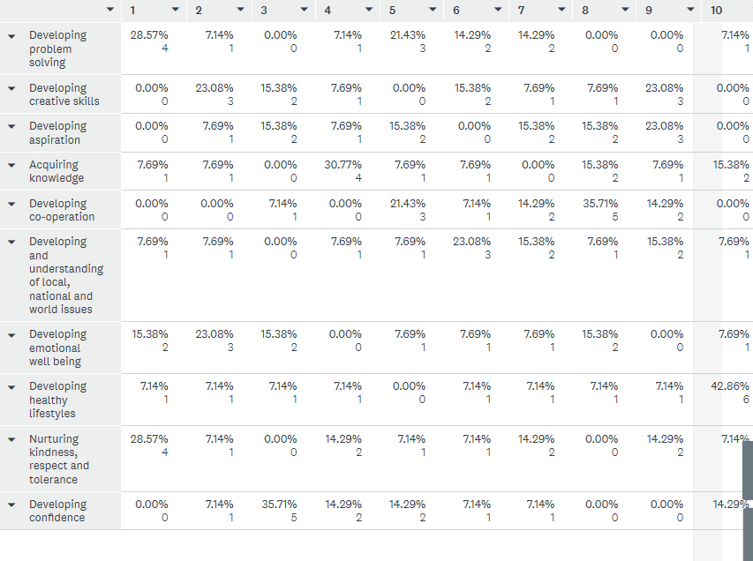

- How satisfied are you that we have the correct number of trips linked to topics and extra experiences for instance visitors and participation in external projects?
Very satisfied | 33.33%  5
Satisfied | 33.33%  5
Neither satisfied nor dissatisfied | 33.33%  5
Dissatisfied | 0.00%  0
Very dissatisfied | 0.00%

- How would you find it easiest to receive information regarding the curriculum/termly theme plans?
Letter | 13.33%  2
Email | 73.33%  11
Website | 6.67%  1
Open Morning/Evening | 6.67%  1
Other | 0.00%  0

- Please write down any other comments you have regarding the curriculum in school.
A variety of responses which included the following praise of the teaching and learning:
- ‘Impressed with the teaching of mental maths, reading and spelling’
- ‘Co-operative and lovely atmosphere’
- ‘Excellent behaviour of pupils’
- ‘Diverse and engaging teaching that has developed love of learning and motivation to acquire new skills and knowledge’
- ‘Engaged my child and learnt a lot skill wise and knowledge, but has also developed social skills, creative ways of thinking and an understanding of the world’
along with the following suggestions for improvement:
- ‘Access via the website’ for information.
- Greater expectation needed of the pupils ‘considering the high child:adult ratio’.
- Preparation support for ‘11 plus exams’
- Transition to secondary school
- Teaching of ‘money management’
- ‘Difficult to rank the key aspects as they are all important’
- ‘Need extra curriculum activities after school…for Year 1 onwards for example extra maths, languages, reading club or science club’.

